# Executive Summary

In this Laboratory a beam/truss bridge that was loaded with a roadbed weight (1500lbs/ft) and four trucks (8000lbs) with a payload weight (57500lbs) was analyzed using ANSYS; the system was constructed in ANSYS using the program’s user interface, then its specific properties (e.g. I-beam dimensions, young’s modulus) were entered into the program. Finally, finite element analysis was conducted on the bridge to determine the maximum stress, to determine whether it was below the allowable limit of 25 kpsi. While conducting the analysis it was determined the maximum stress exceeded the allowable limit, hence a system redesign was necessary. For the original design, it resulted in the maximum deflection to be 4.73509 in and the maximum stress (von mises stress) being 75234.1 kpsi, which was way above the allowable stress of 25 kpsi. As a result, two redesign strategies were developed. For design strategy 1, there was a maximum deformation of 0.716475 in and a maximum stress of 24260.5 kpsi achieved by adding more members to the structure. For design strategy 2, there was a maximum deformation of 2.78878 in and a maximum stress of 24873.2 kpsi, which was achieved by changing the area of the beams in the truss. At the end, based on the overall results and a analysis it was found that design strategy 1 yielded the best and most feasible results.

Table of Contents

Executive Summary i

List of Figures iii

List of Table v

Introduction 1

Objective 1

Apparatus 3

Procedure 3

Results and Discussion 5

Original Design 5

Design Strategy 1 – Adding/Subtracting Frame Member 9

Design Strategy 2 – Changing Cross-Sectional Area of Frame Members 14

Conclusions and Recommendations 19

Material Analysis 20

Original Design Component Breakdown 20

Design Strategy 1 Component Breakdown 20

Difference between Original Design and Design Strategy 1 21

Design Strategy 2 Component Breakdown 21

Difference between Original Design and Design Strategy 2 21

References 22

Appendices 23

# 

# List of Figures

Figure 1. Configuration of the Bridge being analyzed 2

Figure 2. Roadbed I-beam properties 2

Figure 3. Original Design Diagram 5

Figure 4. Original Design Reaction Diagram 6

Figure 5. Original Design Deformation Diagram 6

Figure 6. Original Design Displacement Vector Sum 7

Figure 7. Original Design Von Mises Stress 7

Figure 8. Original Design Maximum Stress 8

Figure 9. Design Strategy 1 Diagram 10

Figure 10. Design Strategy 1 Reaction Diagram 11

Figure 11. Design Strategy 1 Deformation Diagram 11

Figure 12. Design Strategy 1 Displacement Vector Sum 12

Figure 13. Design Strategy 1 Von Mises Stress Diagram 12

Figure 14. Design Strategy 1 Maximum Stress 13

Figure 15. Design Strategy 2 Diagram 15

Figure 16. Design Strategy 2 Reaction Diagram 16

Figure 17. Design Strategy 2 Deformation Diagram 16

Figure 18. Design Strategy 2 Displacement Vector Sum 17

Figure 19. Design Strategy 2 Von Mises Stress Diagram 17

Figure 20. Design Strategy 2 Maximum Stress 18

# List of Table

Table 1. Reaction Forces for Select Nodes (in pounds) for Design Strategy 1 13

Table 2. Reaction Moments for Select Nodes (in inch pounds) Design Strategy 1 14

Table 3. Reaction Forces for Select Nodes (in pounds) Design Strategy 2 18

Table 4. Reaction Moments for Select Nodes (in inch pounds) Design Strategy 2 19

Table 5. Displacement Vectors for Nodes (in inches) for Original Design 23

Table 6. Reaction Forces for Select Nodes (in pounds) for Original Design 24

Table 7. Reaction Moments for Select Nodes (in inch pounds) for Original Design 24

Table 8. Displacement Vectors for Nodes (in inches) for Design Strategy 1 24

Table 9. Displacement Vectors for Nodes (in inches) for Design Strategy 2 26

# Introduction

Analysis of mechanical systems is focused around setting up differential equations based in physical relationship such as equilibrium, conservation of energy, conservation of mass, laws of thermodynamics, and Newton’s laws of motion. Once formulated these equations are then derived and solved based on the system and boundary conditions, however solving these equations is often difficult. Only simple and uniform systems with simple boundary conditions are readily solved.

Finite element analysis is a dominant technique to address the issue of solving complex mechanical systems. Finite element analysis relies on mathematically sub-dividing a complex system into smaller disjoint (non-overlapping) geometric components called elements. Each element is then expressed as an unknown function(s) at nodal points, the unknown variables of the functions are then solved to obtain a solution. The solution of the entire mechanical system is obtained by assembling the individual elements together based on the geometry of the system. Finite element method is a very effective technique which outputs very accurate results. However, solving the functions yielded by finite elements method proves to be tedious and extremely complex. To address this issue softwares are used to conduct the finite element analysis. Computer programs allow the user to input the mechanical they wish to analyze along with system properties and configurations, the software conducts the finite element method analysis and displays the solution.

# Objective

For the purpose of this laboratory, ANSYS, one of the specialize programs designed to conduct finite element analysis was used. ANSYS like all other finite programs, contains a user interface through which the user inputs the mechanical system configuration, design and properties. The program then runs the finite element method on the given system and displays the desired quantities (e.g. stress). The finite elements study was conducted on a truss/beam type bridge. The Bridge spans 200 feet and contains support beams in the middle of it (beams are connected to the concrete post) as seen in Figure 1. The study is conducted assuming four trucks with cab weight 57500lbs, cab weight 8000lbs are equally distributed on a roadbed with accompanying weight of 1500lbs/ft. The roadbed is reinforced with W12-305 I-beams (Figure 2) and the remaining beams are square beams with cross sectional area of 3.8in2.

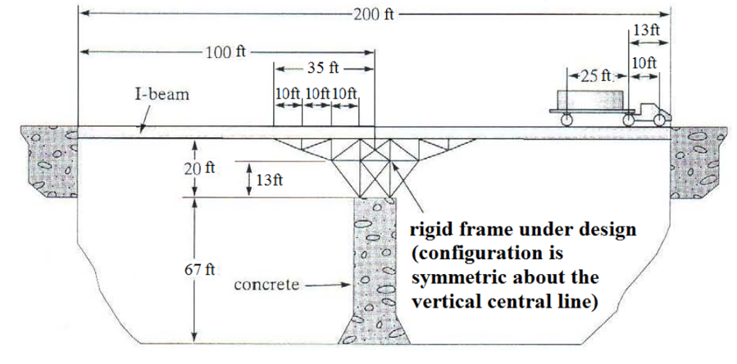

Figure . Configuration of the Bridge being analyzed

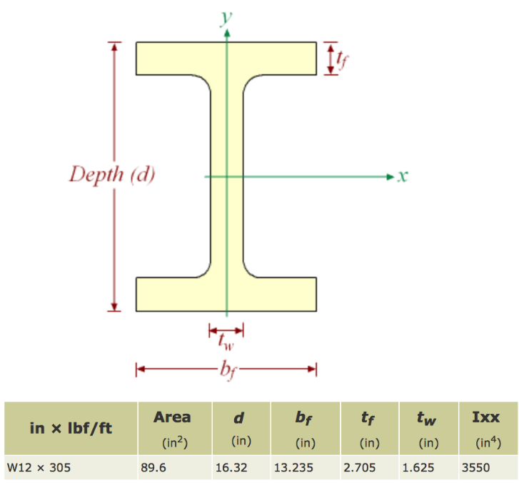

Figure . Roadbed I-beam properties

The study requires the use of ANSYS to first build the bridge using the program’s user interface, then input system properties (e.g. I-beam dimensions and young’s modulus). Once the system is set up in ANSYS, finite element analysis to determine whether the system is safe (i.e. determine if the stress in the entire system surpasses 25 ksi). In case the bridge is determined unsafe, it must be redesigned by:

Adjusting the cross sectional area of square members and I-beam.

OR

Adding and deleting members to render the entire system safe.

Producing a lower displacement vector sums and lower reaction forces/moments are also lesser goals in comparison to reducing the maximum stress below the allowable range.

# Apparatus

* Computer
* Monitor
* Keyboard
* Mouse
* ANSYS software

# Procedure

* Beam element was set through the preprocessor menu by doing the following:
  + Element Type > Add/Edit/Delete > Add: Structural Mass > Beam > 2Node188
* The material models were created through the preprocessor menu by doing the following:
  + For the beams on the truss, Material Properties > Material Models > Structural > Linear > Elastic > Isotropic Set EX=32.5e6, where the poisons ratio ‘PRXY’ was set to 0.0 by default.
  + For the main beam that would be used for the road bed, Material Properties > Material Models (ID set as 2) > Structural > Linear > Elastic > Isotropic Set EX=2.9008e7, where the poisons ratio ‘PRXY’ was set to 0.0 by default.
* To create the beam geometries in the preprocessor menu, the following was done:
  + For the I-beam, Sections > Beam > Common Sections > ID was set to 1 and description set as I-Beam, subtype was selected as I-beam and given dimensions were input as seen in Figure 2.
  + For the truss beams, ID was set to 2 and description set as Truss, subtype was selected as a box beam and given dimensions of approximately 1.95 in were used for both height and width.
* To make the structure, only nodes were used instead of key points to avoid needing to mesh. To do this the points that are given in Figure 1 are modelled by doing the following in the preprocessor menu:
  + Modeling > Create > Nodes > IN Active CS
  + NOTE: All points should be plotted on XZ plane due to the default orientation of the beam sections when implemented
* An additional 9 nodes were added from the fixed points from the furthest left and right walls (95 feet left and 105 feet right from the origin seen in Figure 1) in order to increase the solution accuracy at those points. It was also used to increase the points of applied pressure that will explained later.
  + This was done in the same menu used to create nodes, but instead selecting the option ‘Fill between Nds’ and selecting the points where the nodes will be created in between. The starting node input value should be the next available node number that is not in use.
* To create the elements, from the preprocessor menu the following was done:
  + Initially to select the material type and sections of the elements to be created, Modelling > Create > Elements > Elem Attributes > appropriate material number [MAT] and section number/description were selected.
  + Next in the same ‘Elements.’ Menu, go through: Auto Numbered > Thru Nodes > select the points that the specific material and section type selected will represent. Final model should be similar to Figure 1.
* To apply the boundary conditions, in the Solution menu the following was done:
  + For the fixed points, Define Loads > Apply > Structural > Displacement > Select the fixed nodes and apply all DOF at 0 force.
  + For the Pressure distributed on the top beam, Define Loads > Apply > Structural > Pressure > On Beams > Use a KEY value of 1, and the negative pressure value of -234.1667 was inputted in the ‘I’ node only. It should be noted that the pressure is only applied to the nodes of the beam, thus having added additional nodes earlier increases the points of contact and give a more accurate simulation.
* The model was then solved by going to the Solution menu and solving the ‘Current LS’.
* Through the General Postproc menu, the results for Von Mises Stress and Displacement Vector sum were then plotted on a Nodal solution contour plot along with the deformed shape and edge.
* The data for the elemental stresses, displacement vector sum and the reaction forces and moments were obtained in table form through the ‘List Results > Nodal Solution’ menu in General Postproc.

# Results and Discussion

## Original Design

The Original Design presented many problems for the designers when attempting to model it. Once completed (Figure 3), it was found that there was in fact a need for redesign due to two factors; the maximum deflection was found to be *4.73509 in* (Figures 5 & 6) which is significant for a bridge, as wll as the maximum force being *75234.1 kpsi*. This is well above the allowable stress constraint of 25 kpsi. The stresses on the model as well as the maximum stress can both be found on Figures 7 & 8 respectively. The reaction forces/moments and displacments vector lists can be found listed in the Appendix.

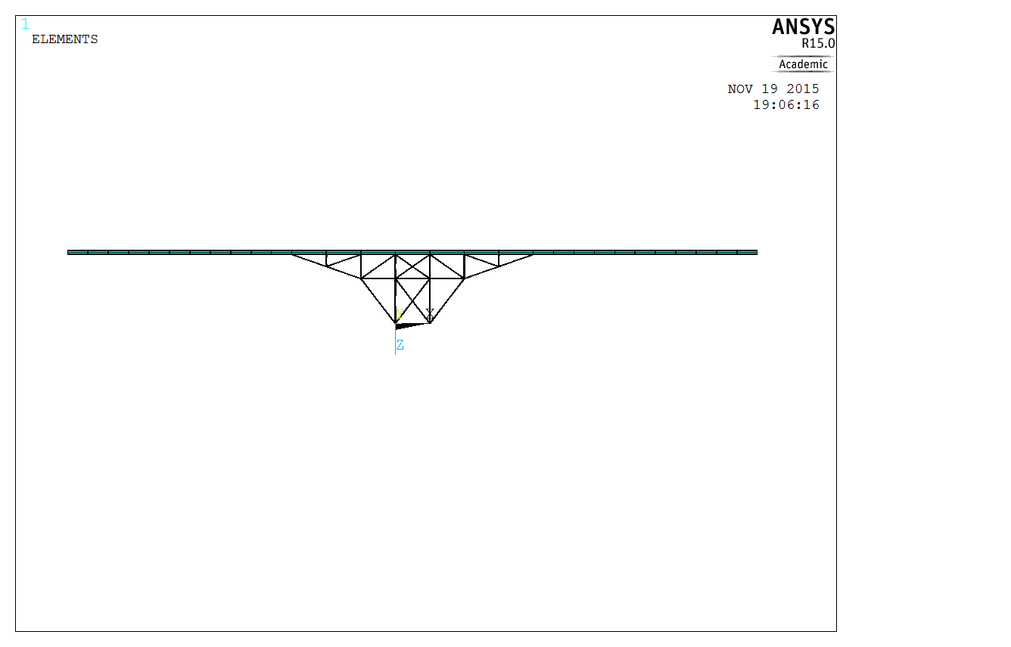

Figure . Original Design Diagram

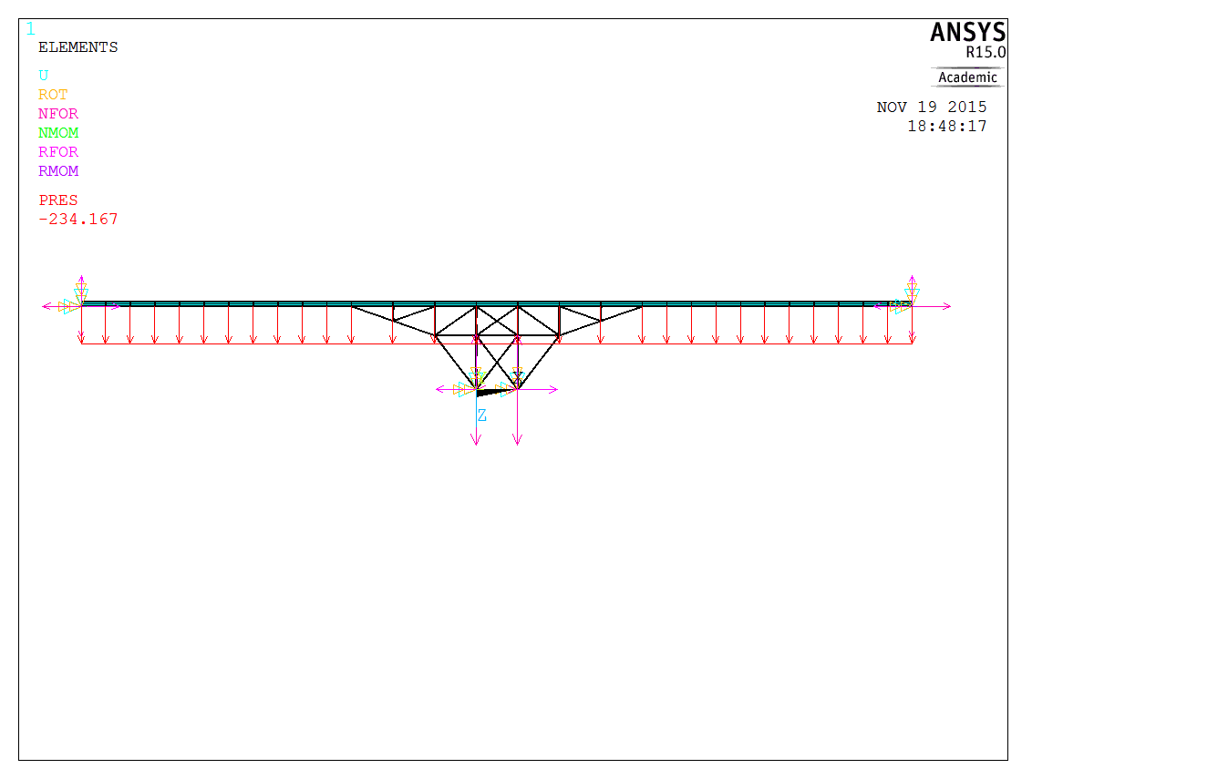

Figure . Original Design Reaction Diagram

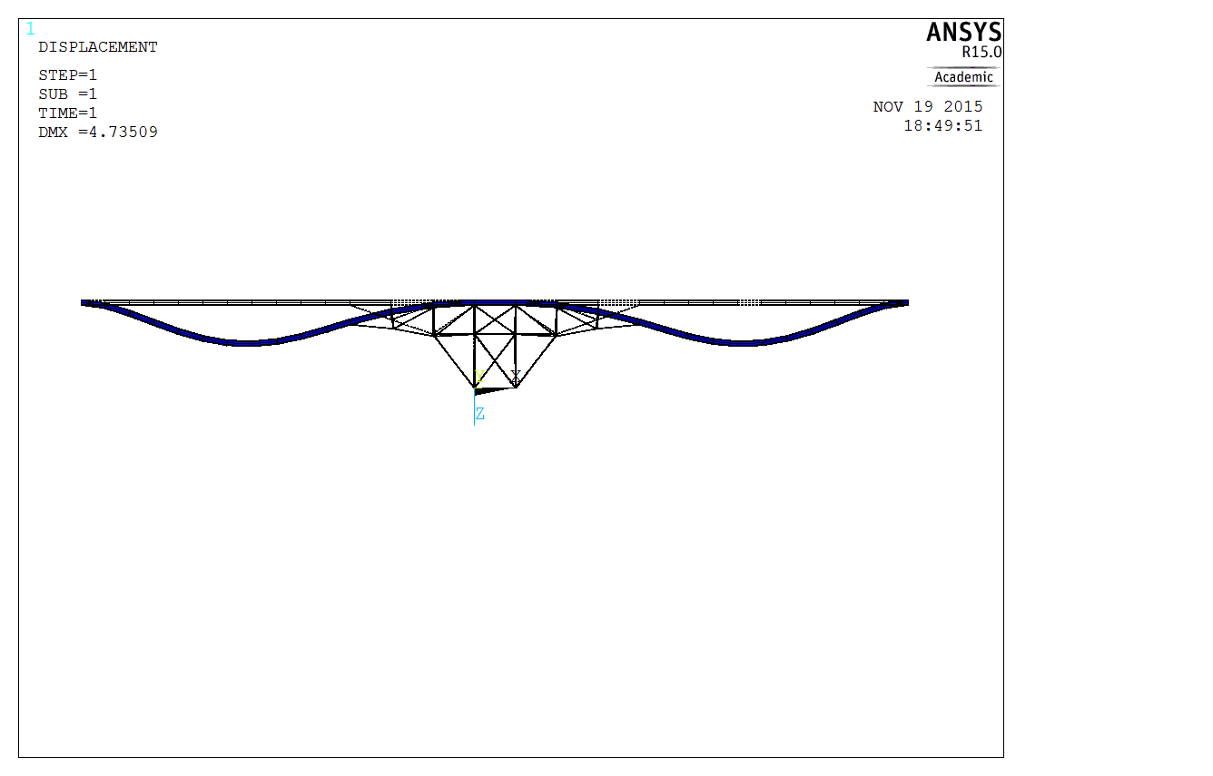

Figure . Original Design Deformation Diagram

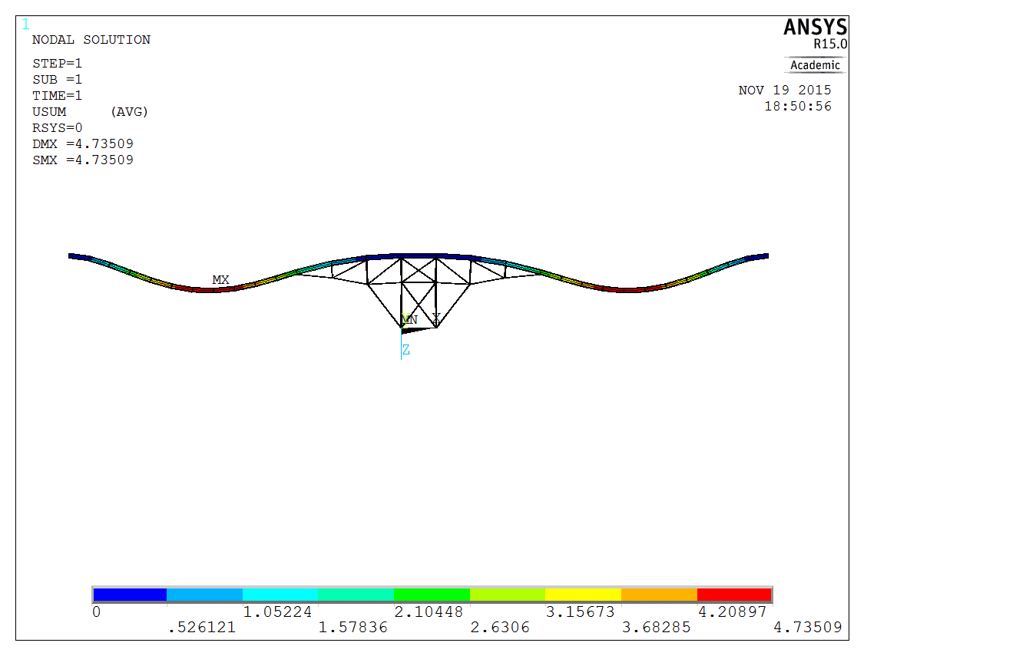

Figure . Original Design Displacement Vector Sum

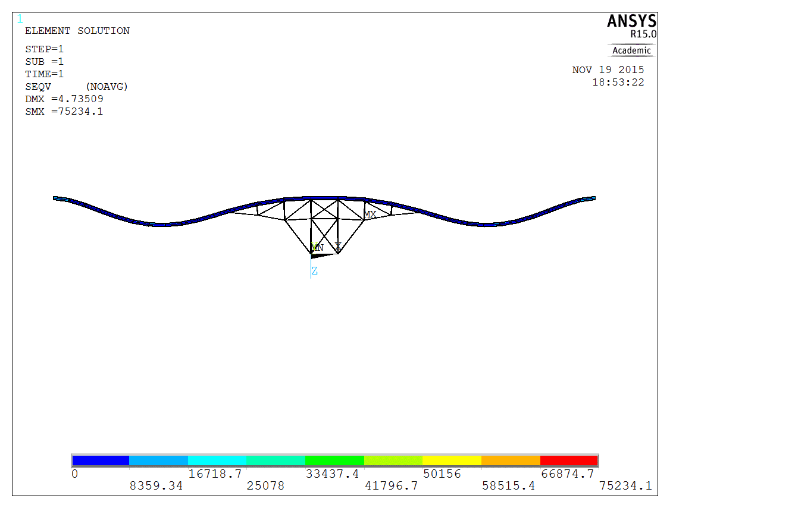

Figure . Original Design Von Mises Stress

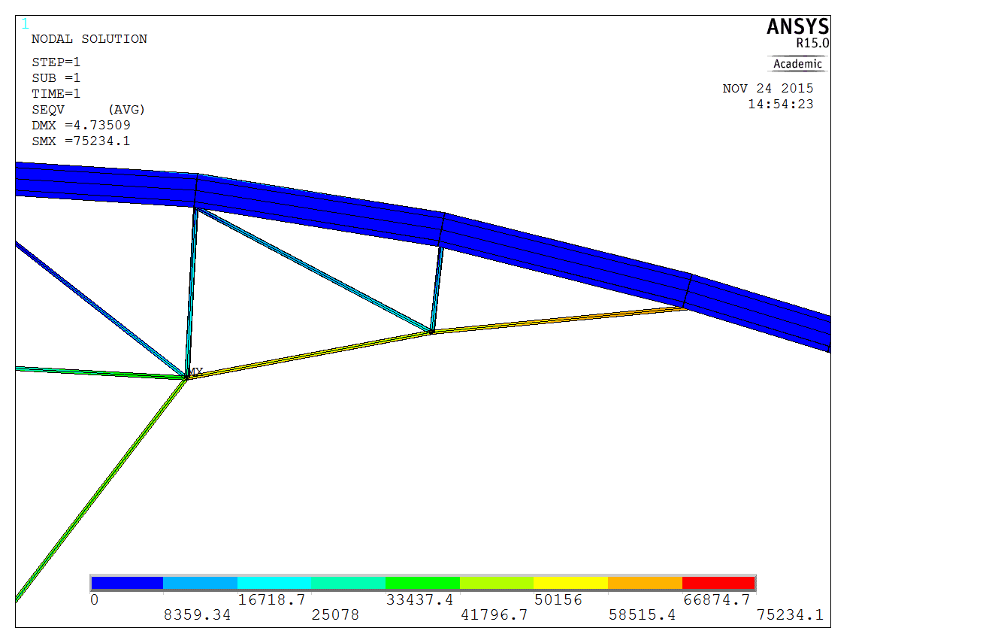

Figure . Original Design Maximum Stress

## Design Strategy 1 – Adding/Subtracting Frame Member

As it was determined that the original design model was unsafe due to the stresses exceeding that of the allowable stress as well as considerable levels of deformation, Design Strategy 1 was conceptualized. Design Strategy 1 utilized the ability to add or remove frame members to the designer’s discretion. It was important that the designers add minimal frame members as cost was initially considered a design parameter. However, after numerous attempts to do so, the decision was made that many frame members were to be added to reduce the stresses to below the maximum allowable stress of *25 kpsi*. Design Strategy 1 looks considerable different than the original design, and most of the frame members from the original design were removed. The design consists of a network of cross beams throughout the length of the roadbed. This ensures that the roadbed will be structurally stable when sustaining heavy loads, as opposed to the original design where there is no reinforcement throughout the length of the roadbed and is evident by the large deflection value. Support beams were added at each extreme of the bridge. It was found that the network of cross beams just barely had a maximum stress greater than the allowable stress, and adding these support beams managed to reduce the maximum stress level to just below *25* *kpsi*. Design Strategy 1 can be seen in Figure 9.

Figure 10 reveals the forces present in this design. The two extremes of the bridge are fixed, as well as the bottom of the rigid frame which is attached to the column of concrete. The pressure value for the distributed loading is *234*.*167* *kpsi* acting in the downward Z-direction.

Figure 11 illustrates the deformation behaviour of Design Strategy 1. It is very similar to that of the original design, however the amount of deformation is greatly reduced. Design Strategy 1 successfully achieves a maximum deflection value of *0.716475* *in*. This results in a *660*% decrease of deflection from the original design.

Figure 12 further demonstrates the displacement levels of Design Strategy 1 with a contour plot. The maximum deflection occurs approximately midway through the fixed end of the roadbed and the central frame configuration and there is minimum deflection at the fixed ends as well as the center of the structure.

Figure 13 presents a contour plot of the stresses present within the members. The maximum stress in this model is located at the fixed end of each the support beam. These beams were implemented to compliment the cross-beam structure and it was predicted that the maximum stress would be found at this location. This stress of *24260.5 kpsi*.

Figure 14 sits just below the allowable maximum stress of *25 kpsi*, therefore these support beams are considered safe. Stresses are evenly distributed in the rigid frame configuration with virtually no zero force members, which demonstrates the effectiveness of this design.

The displacments vector lists can be found listed in the Appendix.

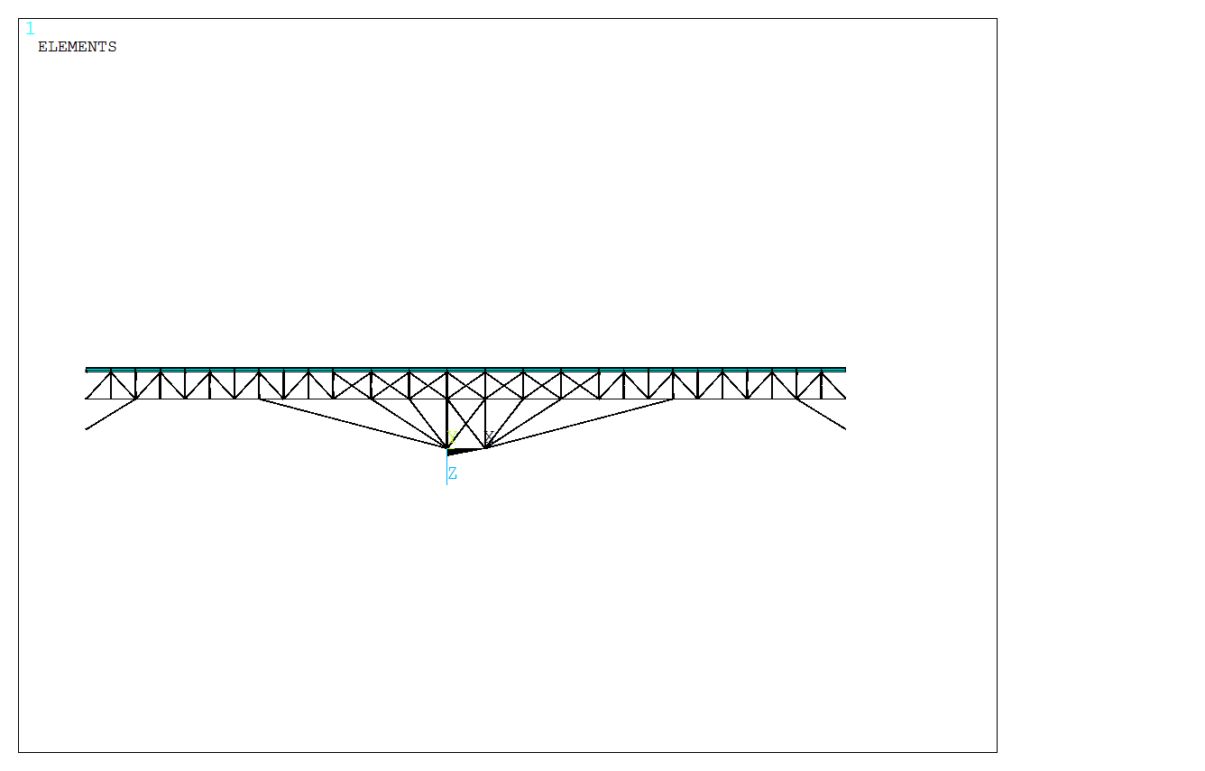

Figure . Design Strategy 1 Diagram

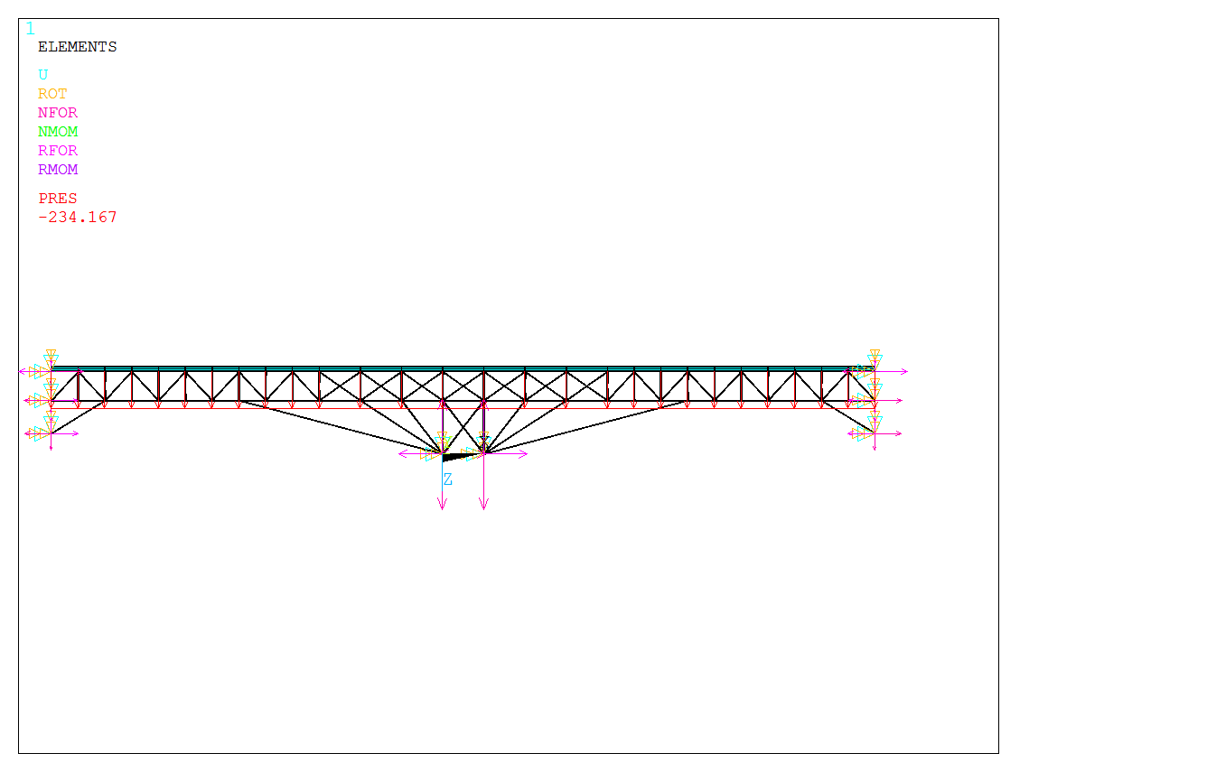

Figure . Design Strategy 1 Reaction Diagram

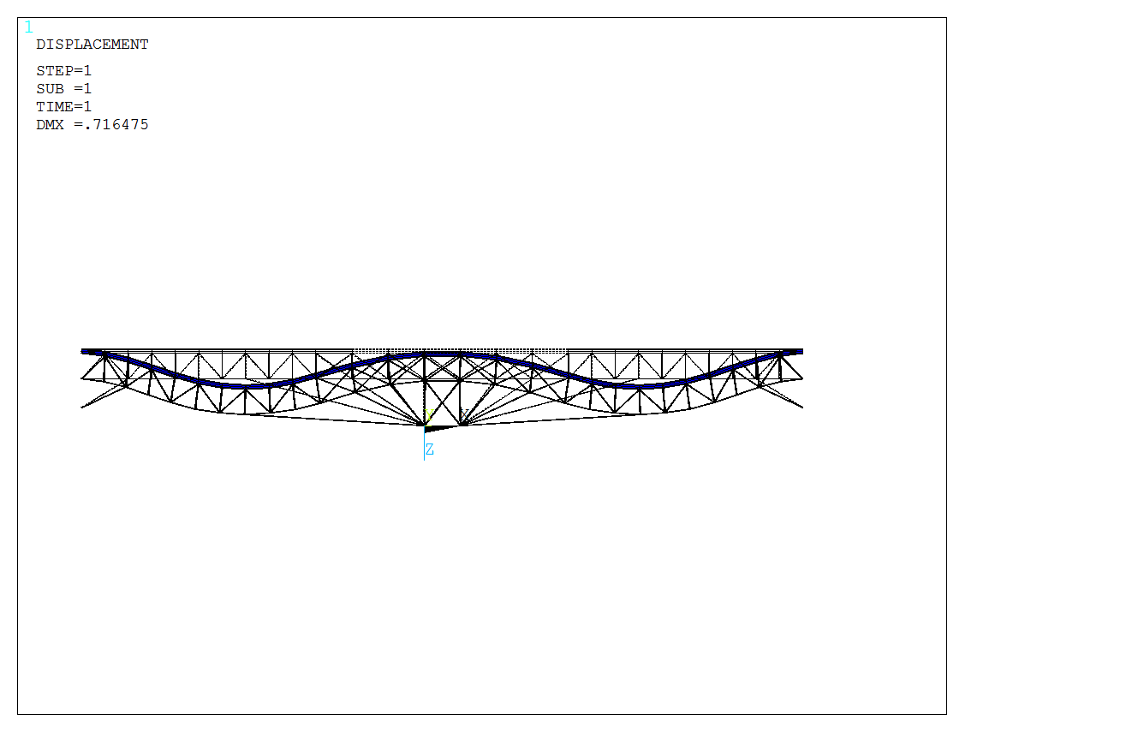

Figure . Design Strategy 1 Deformation Diagram

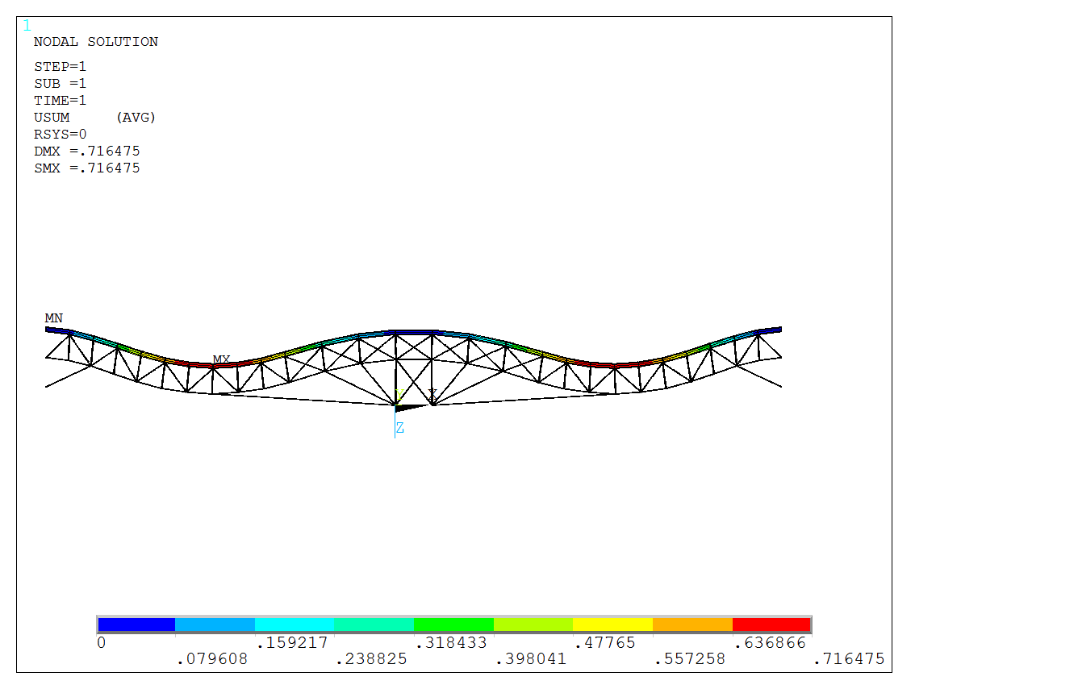

Figure . Design Strategy 1 Displacement Vector Sum

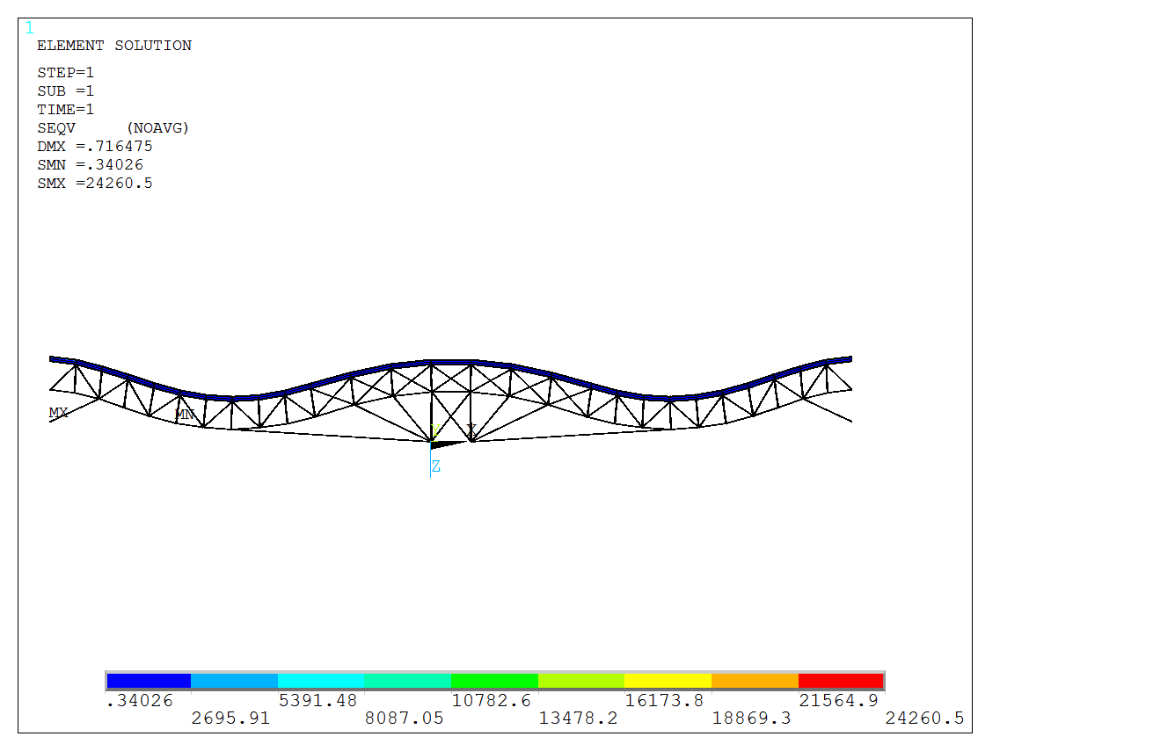

Figure . Design Strategy 1 Von Mises Stress Diagram

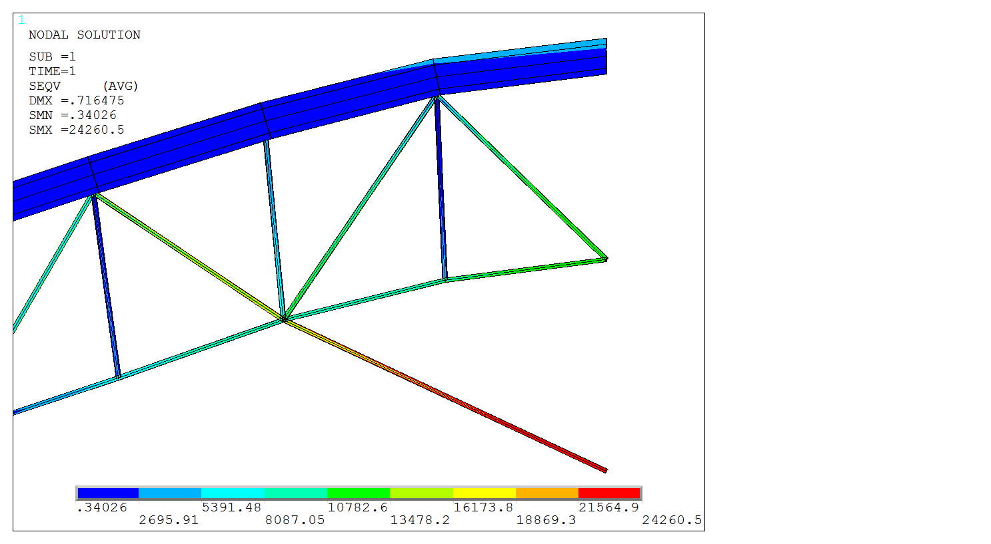

Figure . Design Strategy 1 Maximum Stress

The following tables represent reaction forces and moments for fixed nodes. We are most interested in the forces acting on the Z-direction (FZ). Nodes 1 and 2 have the greatest reaction forces due to the weight of the roadbed and distributed loading as well as the cross-beam configuration all acting on these 2 points. Symmetry is evident as each fixed node to the right of the center of the design is equivalent to its mirror opposite. We are also interested in the moments acting on the Y-Direction (MY). The maximum reaction moment can be found at each fixed end of the I-beam. This makes senseas these points must resist the greatest amount of rotation about its axis. Once again symmetry is present as the moments of each fixed end are equivalent to its mirror opposite, aside from the change of direction.

Table 1. Reaction Forces for Select Nodes (in pounds) for Design Strategy 1

|  |  |  |  |
| --- | --- | --- | --- |
| **Node Number** | **FX** | **FY** | **FZ** |
| **1** | -0.12925E+06 | -0.10964E-08 | -0.16230E+06 |
| **2** | 0.12925E+06 | -0.12498E-08 | -0.16230E+06 |
| **12** | 80341 | -0.18819E-08 | -36296 |
| **13** | -80341 | -0.13680E-08 | -36296 |
| **16** | -95558 | 0.34691E-08 | -34428 |
| **17** | 95558 | 0.28817E-08 | -34428 |
| **59** | 77958 | -0.42738E-09 | -47980 |
| **60** | -77958 | -0.32721E-09 | -47980 |
| **TOTAL** | **0.34925E-09** | **-0.48945E-20** | **-0.56200E+06** |

Table 2. Reaction Moments for Select Nodes (in inch pounds) Design Strategy 1

|  |  |  |  |
| --- | --- | --- | --- |
| **Node Number** | **MX** | **MY** | **MZ** |
| **1** | -0.63894E-07 | -1117.2 | 0.89207E-07 |
| **2** | -0.75648E-07 | 1117.2 | -0.10085E-06 |
| **12** | -0.62829E-07 | 2633.1 | -0.79085E-07 |
| **13** | -0.45567E-07 | -2633.1 | 0.57398E-07 |
| **16** | 0.55594E-06 | 0.33211E+07 | 0.80734E-06 |
| **17** | 0.40775E-06 | -0.33211E+07 | -0.78822E-06 |
| **59** | -0.18597E-07 | 676.30 | -0.37285E-07 |
| **60** | -0.14054E-07 | -676.30 | 0.28615E-07 |
| **TOTAL** | **0.68310E-06** | **0.93017E-08** | **-0.22880E-07** |

## Design Strategy 2 – Changing Cross-Sectional Area of Frame Members

Design Strategy 2 utilized the ability to change the cross sectional area of all frame members without altering the original frame configuration. This proved to be a much simpler task in comparison to Design Strategy 1 as the cross sectional area of the frame can easily be updated with all other configurations for the model kept intact. After a few attempts at altering the cross sectional area, it was found that *6 in x 6 in* square beams resulting in a cross sectional area of *36 in­2*managed to reduce the maximum stress of the system to just below the allowable stress of *25 kpsi*. *36 in2* is a considerably larger area than *3.8in2*, and although Design Strategy 2 was approached with a cost-effectiveness mindset, safety does in fact have priority. Design Strategy 2 is illustrated in Figure 15.

Figure 16 reveals the forces present in this design. Once again, the two extremes of the bridge are fixed, as well as the bottom of the rigid frame which is attached to the column of concrete. The pressure value for the distributed loading is *234*.*167* *kpsi* acting in the downward Z-direction.

Figure 17 illustrates the deformation behaviour of Design Strategy 2. It is very similar to that of the original design, however the amount of deformation is reduced. Design Strategy 2 successfully achieves a maximum deflection value of *2.78878 in*. This results in a 170% decrease of deflection from the original design. Figure 18 further demonstrates the displacement levels of Design Strategy 2 with a contour plot. The maximum deflection occurs approximately midway through the fixed end of the roadbed and the central frame configuration and there is minimum deflection at the fixed ends as well as the center of the structure.

Figure 19 presents a contour plot of the stresses present within the members. The maximum stress is located at the fixed ends on the extremes of the I-beam. This stress of *24873.2 kpsi* is below the maximum allowable stress of 25 *kpsi* and is therefore considered safe. Figure 20 further illustrates the force distribution at this point.

The displacments vector lists can be found listed in the Appendix.

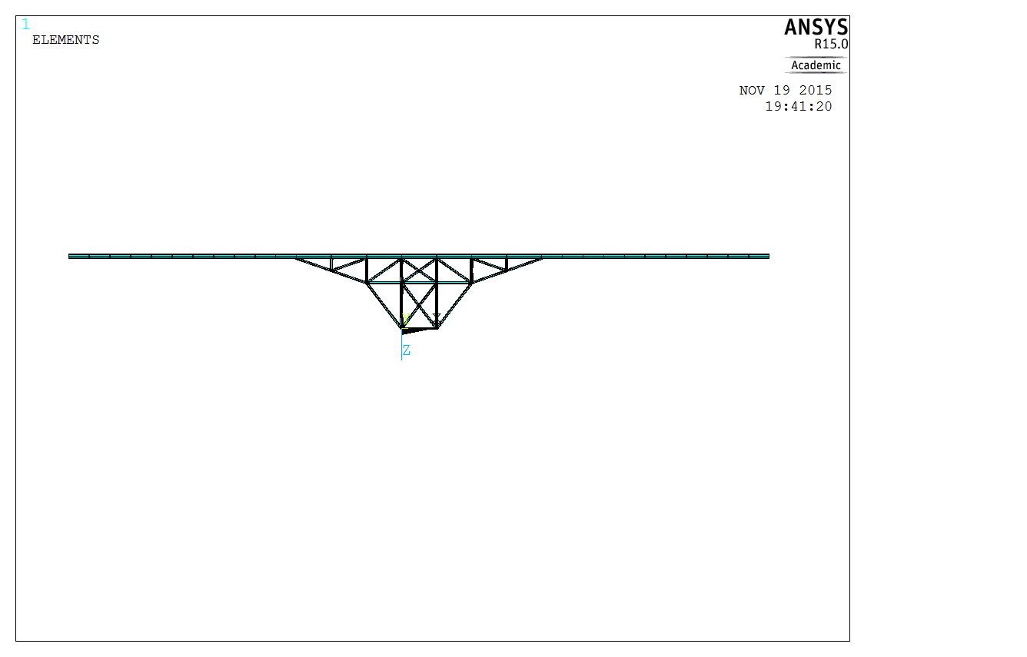

Figure . Design Strategy 2 Diagram

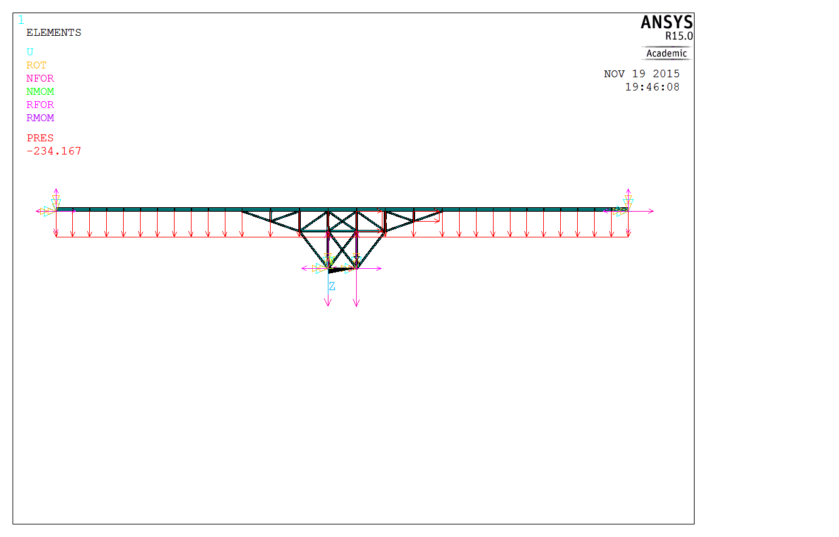

Figure . Design Strategy 2 Reaction Diagram

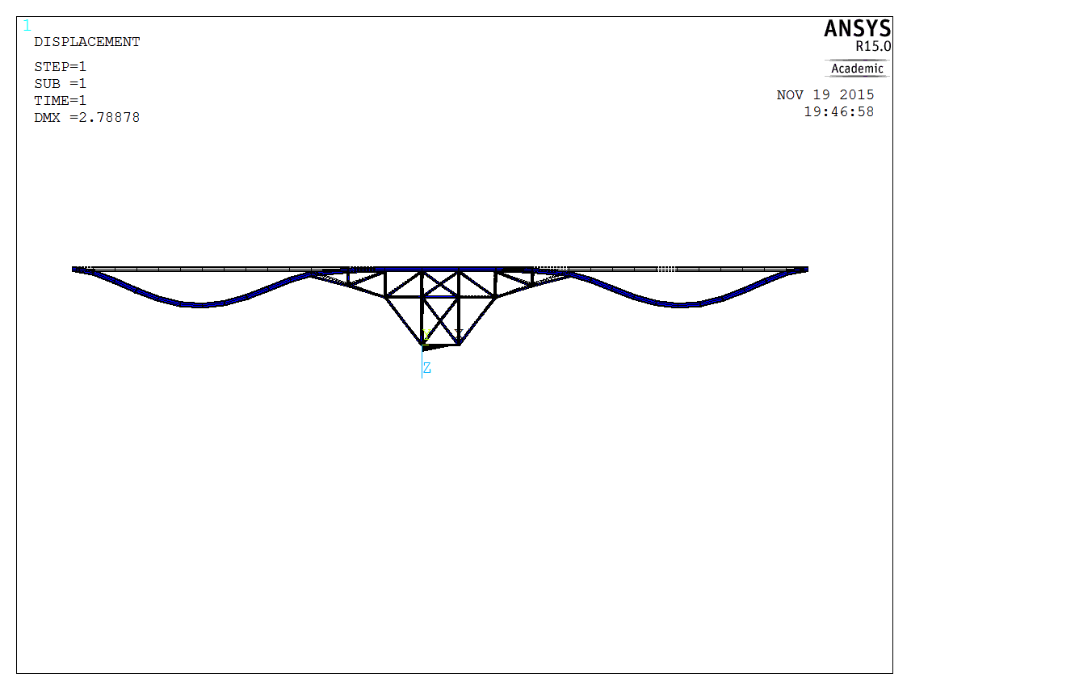

Figure . Design Strategy 2 Deformation Diagram

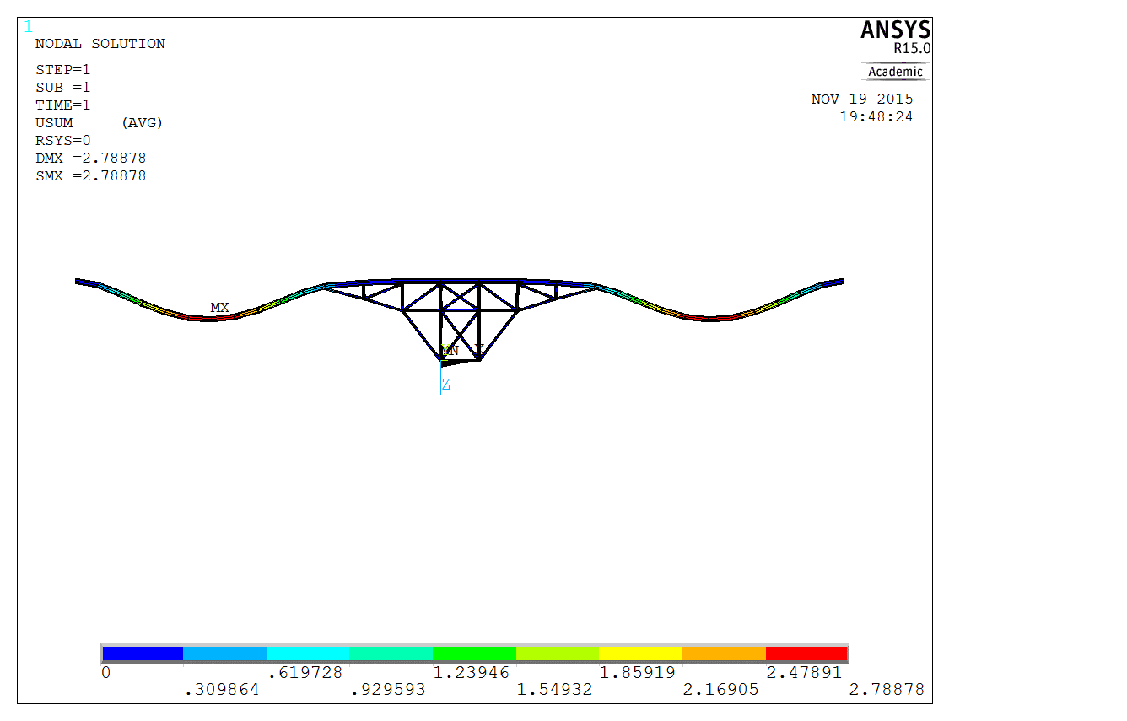

Figure . Design Strategy 2 Displacement Vector Sum

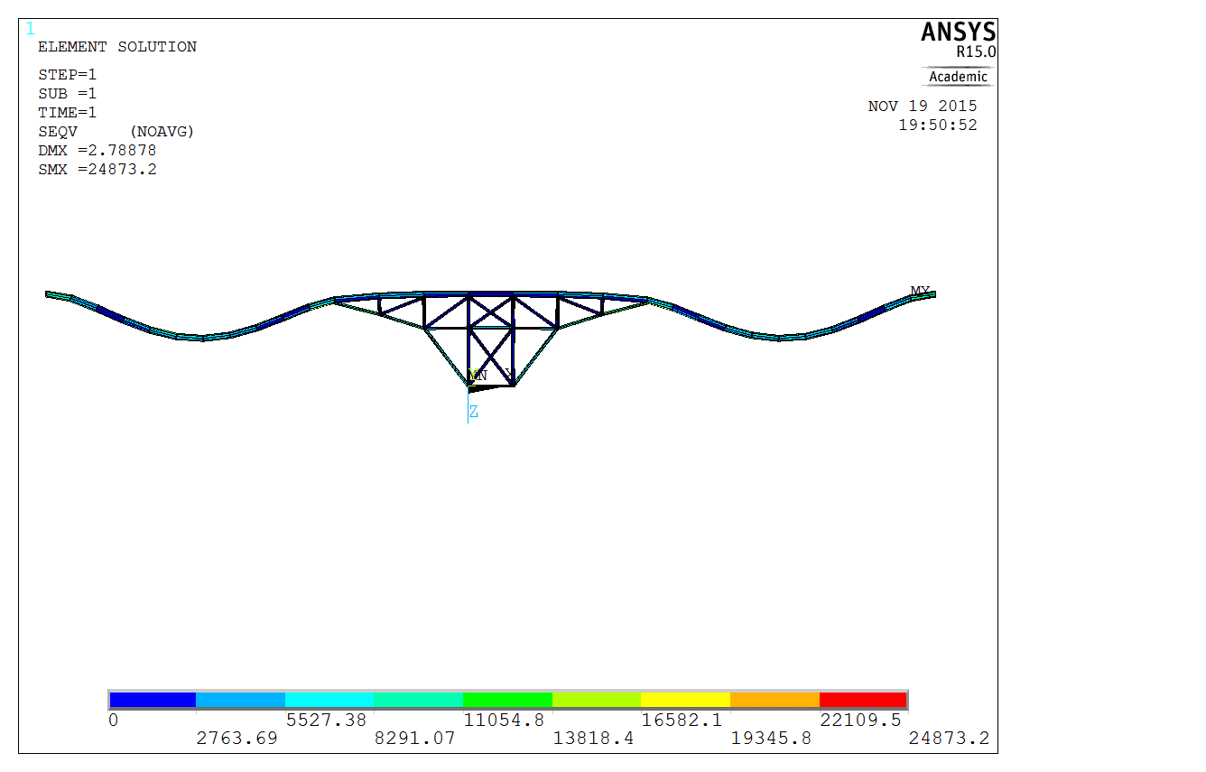

Figure . Design Strategy 2 Von Mises Stress Diagram

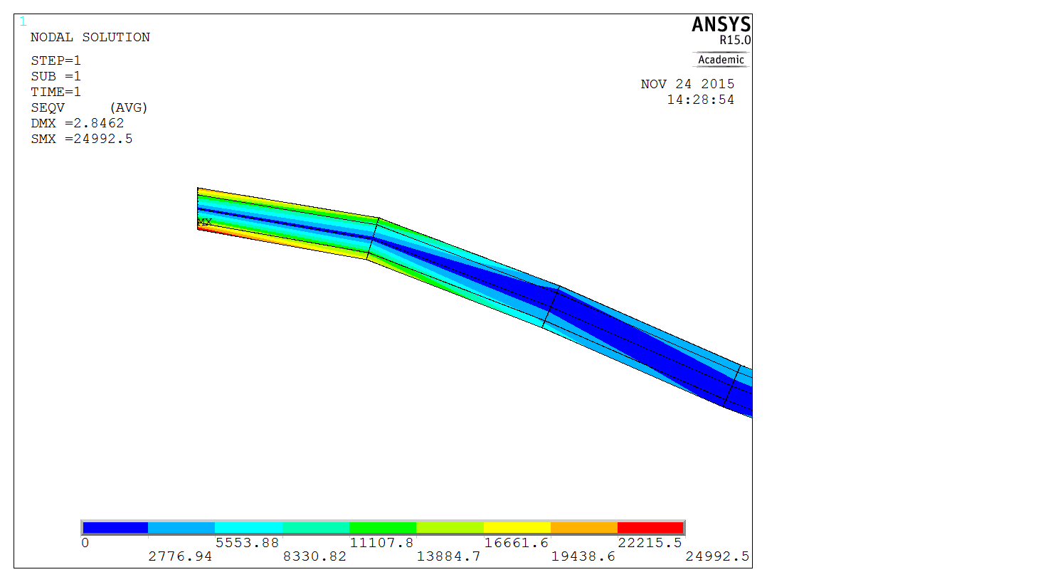

Figure . Design Strategy 2 Maximum Stress

The following tables represent reaction forces and moments for fixed nodes. We are most interested in the forces acting on the Z-direction (FZ). The greatest reaction force is once again found on Nodes 1 and 2. What’s surprising is that these 2 nodes are not of equal value to each other. This may be due to error on the designer`s part as the symmetry of the design should have guaranteed equal forces. We are also interested in the moments acting on the Y-Direction (MY). The maximum reaction moment can be found at each fixed end of the I-beam. Once again this is due to these points having to exhibit the greatest amount of rotational resistance. However, these moments are considerably greater than those of Design Strategy 1 due to there being no cross-beam support under the roadbed.

Table 3. Reaction Forces for Select Nodes (in pounds) Design Strategy 2

|  |  |  |  |
| --- | --- | --- | --- |
| **NODE** | **FX** | **FY** | **FZ** |
| **1** | -0.14860E+06 | -0.75510E-09 | -0.17300E+06 |
| **2** | 0.13755E+06 | -0.17256E-08 | -0.19674E+06 |
| **16** | 0.13576E+06 | 0.10180E-08 | -96136. |
| **17** | -0.15420E+06 | 0.14627E-08 | -96124 |
| **TOTAL** | -29505 | -0.54739E-21 | -0.56200E+06 |

Table 4. Reaction Moments for Select Nodes (in inch pounds) Design Strategy 2

|  |  |  |  |
| --- | --- | --- | --- |
| **NODE** | **FX** | **FY** | **FZ** |
| **1** | 0.14353E-05 | 0.22932E+06 | 0.58827E-06 |
| **2** | 0.14055E-05 | -0.17081E+06 | -0.89082E-06 |
| **16** | 0.22872E-05 | 0.12043E+08 | 0.54386E-06 |
| **17** | 0.14954E-05 | -0.11890E+08 | -0.71675E-06 |
| **TOTAL** | 0.66233E-05 | 0.21089E+06 | -0.47543E-06 |

# 

# Conclusions and Recommendations

It can be concluded that this lab was a success in terms of observing how ANSYS is used to solve real world problems using the Finite Element method. In this lab project, a rigid frame analysis was conducted, as well as the redesigns of the rigid frame.

ANSYS was used for the analysis of a case study. The case study involved using ANSYS for a real world rigid frame analysis and redesign. For the first problem, it involved using ANSYS to build a finite element model to check and observe if the original design was safe. It was determined that the original design was not safe because there was a significant amount of deformation *(4.73509 in*) on the bridge and rigid frame. Also the stress levels on the frame was *75234.1 kpsi* which was higher than the allowable stress of *25 kpsi*. As a result, two other redesigns were made in order to achieve an overall better and safe design.

For the first redesign consideration (Design strategy 1) it involved adding or deleting frame members to modify the frame configuration. The frame material was unchanged. For this redesign a total of 73 frames (beams) were used as can be seen from figure (Design strategy 1 diagram). By adding another layer of beams in a cross shape from one end of the bridge to the other it was able to distribute the stress levels more evenly across the frame, thus resulting in a safer design due to the lower level of stresses in the beam. Also a couple of frames were deleted from the original frame configuration, these were removed because they were zero force members or the stress experienced by them was minimal. Overall, the first redesign resulted in achieving a deformation of *0.716475* *in* and a stress of *24260.5 kpsi,* which was lower than the original design and below the allowable stress of *25 kpsi*. Therefore, it can be observed that design strategy 1 was a safer and more stable design for the rigid frame compared to the original design even though more material was used.

For the second redesign consideration (Design strategy 2) it involved changing the cross sectional area for all the rigid frame members while keeping the original frame configuration. The geometry and all of the parameters remained the same as in the original design. By only increasing the cross sectional area of each individual frame member to 36 in2 from 3.8 in2 it was found that the deformation was *2.78878 in* and the max stress on the overall design was *24873.2 kpsi* which was below the allowable stress. Therefore, it can be observed that design strategy 2 was a safer and more viable design for the rigid frame compared to the original design.

Possible sources of error that may have been made during the completion of the lab project was when entering a value onto ANSYS the consistency of units used may have affected the overall results of the lab. In order to avoid this error units used should be kept consistent when inputting structural information. Another issue that could have affected the results, but was fixed during the completion of the lab was that depending on what plane the I-beam was modelled on ANSYS in could have resulted in different values for the stresses, deflections, and deformations. For example, first the I-beam was modelled on the x-y plane, but that caused the I-beam to be horizontal. Then the I-beam was modelled on the x-z plane and the I-beam was shown to be in the correct orientation (vertical). The main error that would be produced from this lab would be accuracy error, since meshing was to be avoided, a detailed simulation was not possible in order to keep the simulation time low and the model simple. Since the nodes are not all evenly spaced, the simulation may have lost some accuracy. Meshing would be a viable if accuracy was required, this this case study was only to analyze the behavior and not necessarily to produce precise results.

## Material Analysis

### Original Design Component Breakdown

2 beams x 13 ft = 26 ft

4 beams x 16.4 ft = 65.4 ft

3 beams x 10 ft = 30 ft

4 beams x 7 ft = 28 ft

4 beams x 12.21 ft = 48.84 ft

2 beams x 3.5 ft = 7 ft

2 beams x 21.19 ft = 42.38 ft

2 beams x 10.59 ft = 21.18 ft

Total

23 beams = 268.8 ft = 3225.6 in

Area = 3.8 in2

*VOriginal* = *A x l* = 12257.28 in3 of steel

### Design Strategy 1 Component Breakdown

1 beam x 200 ft = 200 ft

20 beams x 9.55 ft = 191 ft

26 beams x 7 ft = 182 ft

14 beams x 12.2 ft = 170.8 ft

2 beams x 14.76 ft = 29.52 ft

2 beams x 13 ft = 26 ft

4 beams x 16.4 ft = 65.6 ft

2 beams x 22.36 ft = 44.72

2 beams x 51.17 ft = 102.35 ft

Total

73 beams = 1012 ft = 12143.9 in

Area = 3.8 in2

VDS1 = A x l = 46146.744 in3

### Difference between Original Design and Design Strategy 1

*VDS1 – VOriginal =* 33889.464 in3

### Design Strategy 2 Component Breakdown

2 beam x 13 ft = 26 ft

4 beams x 16.4 ft = 65.4 ft

3 beams x 10 ft = 30 ft

4 beams x 7 ft = 28 ft

4 beams x 12.21 ft = 48.84 ft

2 beams x 3.5 ft = 7 ft

2 beams x 21.19 ft = 42.38 ft

2 beams x 10.59 ft = 21.18 ft

Total

23 beams = 268.8 ft = 3225.6 in

Area of Each Beam = 6 in x 6 in = 36 in2

Volume of Steel = *A x l* = 116121.6 in3 of steel

### Difference between Original Design and Design Strategy 2

*VDS2 – VOriginal =* 103864.32 in3

*(Considerably more volume of steel for DS2 compared to DS1)*

Based on the material analysis of the three designs, and different design geometries of each design, it is recommended that the best design strategy to implement for this case study was design strategy 1 because it yielded the safest, most stable, and most economically efficient results. Design strategy 1 had a max deformation of *0.716475* *in* and a max stress of *24260.5 kpsi*, which were better compared to the other designs. Also it was noted that design strategy 1 used less overall material compared to design strategy 2, which results in design strategy 1 being more economically efficient compared to design strategy 2.

# References

[1]Logan, Daryl L. A First Course in the Finite Element Method Using Algor. 2nd ed. Australia: Brooks/Cole Pub., 2001. Print.

[2] Jun, Cao. “Lab3_ ridgid.frame”. Lab handbook. Ryerson University, Toronto, Print.

# Appendices

Table 5. Displacement Vectors for Nodes (in inches) for Original Design

|  |  |  |  |  |
| --- | --- | --- | --- | --- |
| Node Number | Displacement X | Displacement Y | Displacement Z | Vector Sum |
| 1 | 0 | 0 | 0 | 0 |
| 2 | 0 | 0 | 0 | 0 |
| 3 | 5.04E-02 | -1.31E-12 | -7.63E-04 | 5.04E-02 |
| 4 | 3.59E-03 | -3.06E-11 | -4.82E-03 | 6.01E-03 |
| 5 | -5.04E-02 | -8.15E-13 | -7.63E-04 | 5.04E-02 |
| 6 | -3.59E-03 | -3.05E-11 | -4.82E-03 | 6.01E-03 |
| 7 | -0.19045 | 8.35E-12 | 0.25482 | 0.31813 |
| 8 | -2.09E-02 | -2.82E-11 | 0.29695 | 0.29768 |
| 9 | 0.19045 | 5.87E-12 | 0.25482 | 0.31813 |
| 10 | 2.09E-02 | -2.85E-11 | 0.29695 | 0.29768 |
| 11 | -4.74E-02 | -2.43E-11 | 1.0475 | 1.0486 |
| 12 | -0.22713 | 5.78E-12 | 1.0361 | 1.0607 |
| 13 | 0.22713 | 2.25E-12 | 1.0361 | 1.0607 |
| 14 | 4.74E-02 | -2.48E-11 | 1.0475 | 1.0486 |
| 15 | 6.54E-02 | -2.00E-11 | 2.2232 | 2.2241 |
| 16 | 0 | 0 | 0 | 0 |
| 17 | 0 | 0 | 0 | 0 |
| 18 | -6.54E-02 | -1.93E-11 | 2.2232 | 2.2241 |
| 19 | -7.80E-02 | 9.57E-13 | 0.36222 | 0.37051 |
| 20 | -0.11923 | 1.19E-12 | 1.2165 | 1.2223 |
| 21 | -0.13044 | 7.16E-13 | 2.2727 | 2.2764 |
| 22 | -0.11822 | -4.12E-13 | 3.2985 | 3.3006 |
| 23 | -8.92E-02 | -2.14E-12 | 4.1192 | 4.1202 |
| 24 | -5.01E-02 | -4.41E-12 | 4.6178 | 4.6181 |
| 25 | -7.44E-03 | -7.12E-12 | 4.7351 | 4.7351 |
| 26 | 3.21E-02 | -1.02E-11 | 4.4693 | 4.4694 |
| 27 | 6.18E-02 | -1.34E-11 | 3.8766 | 3.8771 |
| 28 | 7.51E-02 | -1.67E-11 | 3.0707 | 3.0716 |
| 29 | -7.51E-02 | -1.60E-11 | 3.0707 | 3.0716 |
| 30 | -6.18E-02 | -1.28E-11 | 3.8766 | 3.8771 |
| 31 | -3.21E-02 | -9.81E-12 | 4.4693 | 4.4694 |
| 32 | 7.44E-03 | -7.03E-12 | 4.7351 | 4.7351 |
| 33 | 5.01E-02 | -4.60E-12 | 4.6178 | 4.6181 |
| 34 | 8.92E-02 | -2.56E-12 | 4.1192 | 4.1202 |
| 35 | 0.11822 | -9.78E-13 | 3.2985 | 3.3006 |
| 36 | 0.13044 | 1.19E-13 | 2.2727 | 2.2764 |
| 37 | 0.11923 | 6.86E-13 | 1.2165 | 1.2223 |

Table 6. Reaction Forces for Select Nodes (in pounds) for Original Design

|  |  |  |  |
| --- | --- | --- | --- |
| Node Number | FX | FY | FZ |
| 1 | -1.10E+05 | -7.40E-09 | -1.73E+05 |
| 2 | 1.10E+05 | -8.22E-09 | -1.73E+05 |
| 16 | 85941 | 7.76E-09 | -1.08E+05 |
| 17 | -85941 | 7.86E-09 | -1.08E+05 |

Table 7. Reaction Moments for Select Nodes (in inch pounds) for Original Design

|  |  |  |  |
| --- | --- | --- | --- |
| Node Number | MX | MY | MZ |
| 1 | -5.30E-07 | 12203 | 2.13E-07 |
| 2 | -5.94E-07 | -12203 | -2.41E-07 |
| 16 | 6.24E-06 | 1.63E+07 | 4.64E-06 |
| 17 | 4.93E-06 | -1.63E+07 | -4.68E-06 |

Table 8. Displacement Vectors for Nodes (in inches) for Design Strategy 1

|  |  |  |  |  |
| --- | --- | --- | --- | --- |
| Node Number | Displacement X | Displacement Y | Displacement Z | Vector Sum |
| 1 | 0 | 0 | 0 | 0 |
| 2 | 0 | 0 | 0 | 0 |
| 3 | 1.26E-02 | -1.14E-12 | 4.03E-02 | 4.23E-02 |
| 4 | -8.76E-04 | -4.72E-12 | 5.57E-02 | 5.57E-02 |
| 5 | -1.26E-02 | -1.08E-12 | 4.03E-02 | 4.23E-02 |
| 6 | 8.76E-04 | -4.72E-12 | 5.57E-02 | 5.57E-02 |
| 7 | -3.71E-02 | -3.33E-13 | 0.11539 | 0.12121 |
| 8 | 1.86E-03 | -4.44E-12 | 0.13347 | 0.13348 |
| 9 | 3.71E-02 | -5.36E-13 | 0.11539 | 0.12121 |
| 10 | -1.86E-03 | -4.45E-12 | 0.13347 | 0.13348 |
| 11 | 1.61E-03 | -3.91E-12 | 0.28476 | 0.28476 |
| 12 | 0 | 0 | 0 | 0 |
| 13 | 0 | 0 | 0 | 0 |
| 14 | -1.61E-03 | -3.93E-12 | 0.28476 | 0.28476 |
| 15 | 3.29E-04 | -3.23E-12 | 0.48378 | 0.48378 |
| 16 | 0 | 0 | 0 | 0 |
| 17 | 0 | 0 | 0 | 0 |
| 18 | -3.29E-04 | -3.20E-12 | 0.48378 | 0.48378 |
| 19 | -6.77E-03 | 5.59E-14 | 5.62E-02 | 5.66E-02 |
| 20 | -1.07E-02 | 9.80E-15 | 0.175 | 0.17532 |
| 21 | -1.07E-02 | -1.48E-13 | 0.32049 | 0.32067 |
| 22 | -1.30E-02 | -4.08E-13 | 0.47491 | 0.47508 |
| 23 | -1.02E-02 | -7.57E-13 | 0.60352 | 0.60361 |
| 24 | -8.83E-03 | -1.18E-12 | 0.68508 | 0.68514 |
| 25 | -6.43E-03 | -1.67E-12 | 0.71641 | 0.71643 |
| 26 | -3.42E-03 | -2.19E-12 | 0.68969 | 0.6897 |
| 27 | -1.37E-03 | -2.72E-12 | 0.60969 | 0.6097 |
| 28 | 1.37E-03 | -2.70E-12 | 0.60969 | 0.6097 |
| 29 | 3.42E-03 | -2.20E-12 | 0.68969 | 0.6897 |
| 30 | 6.43E-03 | -1.71E-12 | 0.71641 | 0.71643 |
| 31 | 8.83E-03 | -1.25E-12 | 0.68508 | 0.68514 |
| 32 | 1.02E-02 | -8.42E-13 | 0.60352 | 0.60361 |
| 33 | 1.30E-02 | -5.01E-13 | 0.47491 | 0.47508 |
| 34 | 1.07E-02 | -2.35E-13 | 0.32049 | 0.32067 |
| 35 | 1.07E-02 | -5.67E-14 | 0.175 | 0.17532 |
| 36 | 6.77E-03 | 2.21E-14 | 5.62E-02 | 5.66E-02 |
| 37 | 7.67E-02 | 2.83E-12 | 0.4867 | 0.49271 |
| 38 | -2.95E-02 | 5.57E-13 | 5.63E-02 | 6.35E-02 |
| 39 | -5.87E-02 | 1.84E-12 | 0.16347 | 0.1737 |
| 40 | -7.87E-02 | 3.43E-12 | 0.32039 | 0.32992 |
| 41 | -9.85E-02 | 4.60E-12 | 0.46915 | 0.47937 |
| 42 | -7.74E-02 | 5.23E-12 | 0.60337 | 0.60832 |
| 43 | -5.62E-02 | 5.47E-12 | 0.67331 | 0.67566 |
| 44 | -2.69E-02 | 5.03E-12 | 0.7109 | 0.71141 |
| 45 | 2.13E-02 | 4.38E-12 | 0.67697 | 0.67731 |
| 46 | 4.91E-02 | 3.75E-12 | 0.60961 | 0.61158 |
| 47 | -7.67E-02 | 3.35E-12 | 0.4867 | 0.49271 |
| 48 | -4.91E-02 | 4.16E-12 | 0.60961 | 0.61158 |
| 49 | -2.13E-02 | 4.53E-12 | 0.67697 | 0.67731 |
| 50 | 2.69E-02 | 4.87E-12 | 0.7109 | 0.71141 |
| 51 | 5.62E-02 | 5.02E-12 | 0.67331 | 0.67566 |
| 52 | 7.74E-02 | 4.53E-12 | 0.60337 | 0.60832 |
| 53 | 9.85E-02 | 3.78E-12 | 0.46915 | 0.47937 |
| 54 | 7.87E-02 | 2.69E-12 | 0.32039 | 0.32992 |
| 55 | 5.87E-02 | 1.39E-12 | 0.16347 | 0.1737 |
| 56 | 2.95E-02 | 4.09E-13 | 5.63E-02 | 6.35E-02 |
| 57 | 5.79E-02 | 9.30E-13 | 0.26907 | 0.27523 |
| 58 | -5.79E-02 | 1.34E-12 | 0.26907 | 0.27523 |
| 59 | 0 | 0 | 0 | 0 |
| 60 | 0 | 0 | 0 | 0 |

Table 9. Displacement Vectors for Nodes (in inches) for Design Strategy 2

|  |  |  |  |  |
| --- | --- | --- | --- | --- |
| Node Number | Displacement X | Displacement Y | Displacement Z | Vector Sum |
| 1 | 0 | 0 | 0 | 0 |
| 2 | 0 | 0 | 0 | 0 |
| 3 | 9.76E-03 | -1.51E-12 | -3.19E-03 | 1.03E-02 |
| 4 | -5.08E-04 | -3.25E-12 | -4.35E-03 | 4.38E-03 |
| 5 | -4.24E-03 | -1.55E-12 | -1.81E-03 | 4.61E-03 |
| 6 | 7.87E-03 | -3.35E-12 | -2.98E-03 | 8.42E-03 |
| 7 | -2.10E-02 | -1.05E-12 | 2.84E-02 | 3.53E-02 |
| 8 | 1.53E-02 | -3.35E-12 | 3.02E-02 | 3.39E-02 |
| 9 | 2.66E-02 | -1.07E-12 | 2.44E-02 | 3.60E-02 |
| 10 | -8.49E-03 | -3.07E-12 | 2.61E-02 | 2.75E-02 |
| 11 | 2.42E-02 | -3.21E-12 | 0.13224 | 0.13445 |
| 12 | -2.45E-02 | -1.27E-12 | 0.13284 | 0.13507 |
| 13 | 3.09E-02 | -1.32E-12 | 0.12726 | 0.13096 |
| 14 | -1.78E-02 | -2.81E-12 | 0.12669 | 0.12794 |
| 15 | -9.87E-03 | -2.36E-12 | 0.37493 | 0.37506 |
| 16 | 0 | 0 | 0 | 0 |
| 17 | 0 | 0 | 0 | 0 |
| 18 | 1.56E-02 | -2.77E-12 | 0.37872 | 0.37904 |
| 19 | -6.03E-02 | 4.45E-13 | 0.27544 | 0.28196 |
| 20 | -8.88E-02 | 7.73E-13 | 0.89889 | 0.90327 |
| 21 | -9.22E-02 | 9.53E-13 | 1.6229 | 1.6255 |
| 22 | -7.70E-02 | 9.65E-13 | 2.2576 | 2.2589 |
| 23 | -4.99E-02 | 8.04E-13 | 2.671 | 2.6715 |
| 24 | -1.76E-02 | 4.80E-13 | 2.7887 | 2.7887 |
| 25 | 1.33E-02 | 1.80E-14 | 2.5939 | 2.5939 |
| 26 | 3.61E-02 | -5.42E-13 | 2.1276 | 2.1279 |
| 27 | 4.43E-02 | -1.15E-12 | 1.4885 | 1.4891 |
| 28 | 3.12E-02 | -1.77E-12 | 0.83291 | 0.8335 |
| 29 | -2.60E-02 | -2.05E-12 | 0.83535 | 0.83576 |
| 30 | -3.97E-02 | -1.36E-12 | 1.4899 | 1.4904 |
| 31 | -3.20E-02 | -7.31E-13 | 2.1283 | 2.1285 |
| 32 | -9.69E-03 | -2.13E-13 | 2.5941 | 2.5941 |
| 33 | 2.07E-02 | 1.72E-13 | 2.7886 | 2.7886 |
| 34 | 5.25E-02 | 4.19E-13 | 2.6708 | 2.6713 |
| 35 | 7.90E-02 | 5.33E-13 | 2.2574 | 2.2587 |
| 36 | 9.37E-02 | 5.33E-13 | 1.6227 | 1.6254 |
| 37 | 8.98E-02 | 4.38E-13 | 0.89876 | 0.90324 |